***SMART IRRIGATION SYSTEM***

**AIM:-**

To control the water supply of the crops in the farm according to the crops need of moisture or irrigation.

**Motivation:-**

we know that Indian economy is mainly based on agriculture. In agriculture effective use of water is a very important factor that’s why we should focus on effective useability of water in agriculture. This project is based on soil moisture content of soil. With this we can provide sufficient water to the fields and avoid water wastage.

**THEORY:-**

The smart irrigation system or automatic plant watering system is the solution to the modern era. We are using Arduino to control and sense the data from sensors. The Arduino Will measure the moisture level using a soil moisture sensor. If the soil moisture is less than the desired value the Arduino will turn ON the relay module that will turn ON the DC pump. The water pump will remain turn ON until the moisture level of the soil reaches the desired value. After that, the pump will be turned OFF by Arduino.

**MATERIAL REQUIRED: -**

1. **HARDWARE: -**
   * + Arduino UNO
     + Soil Moisture sensor
     + Water pump
     + One channel Relay
     + Breadboard
     + Jumper wires
     + 9V battery
2. **SOFTWARE: -**
   * + Arduino IDE

**PIN DAIGRAM: -**

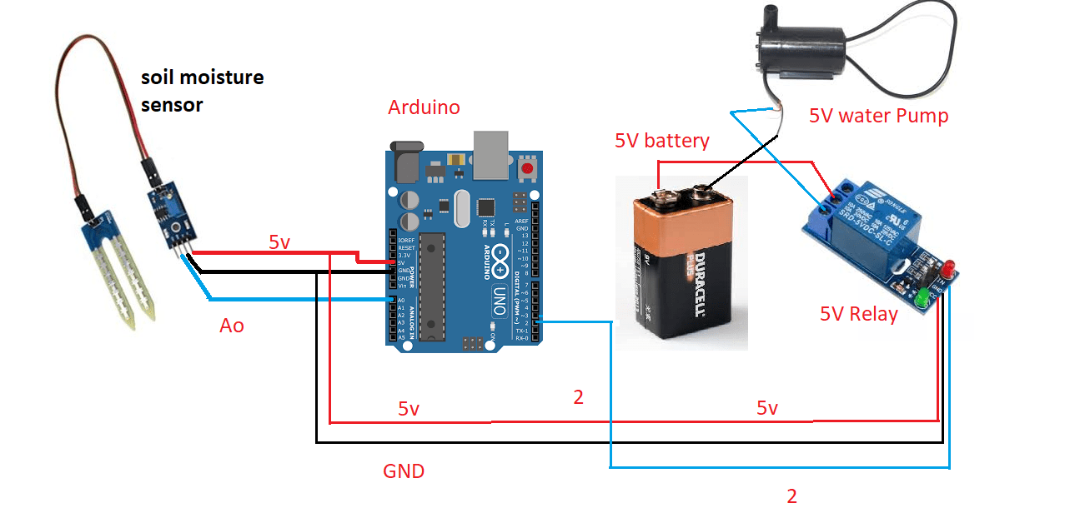

**CODE: -**

int sensor_pin= A0;

int output_value;

void setup(){

pinMode(3, OUTPUT);

Serial.begin(9600);

Serial.println("Reading from the Moisture sensor…");

}

void loop()

{

output_value= analogRead (sensor_pin);

output_value= map (output_value,550,10,0,100);

Serial.print("Moisture:");

Serial.print(output_value);

Serial.println("%");

if (output_value<0)

{

delay(1000);

digitalWrite(3, LOW);

}

else

{

delay(1000);

digitalWrite (3,HIGH);

}

delay (1000);

}

**Serial Monitor: -**

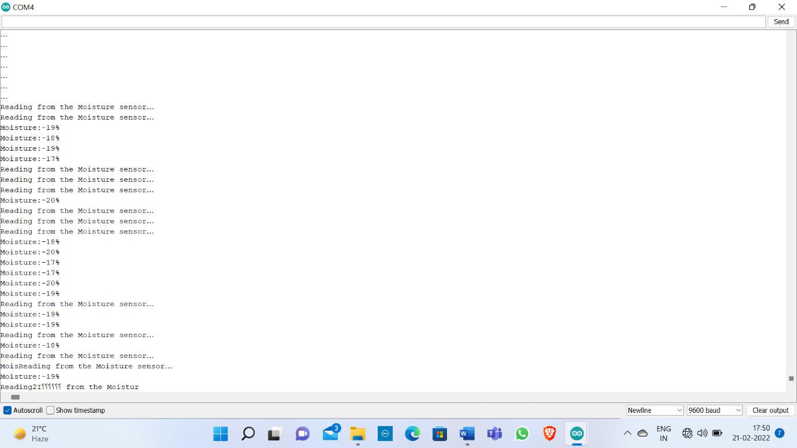

**APPLICATION: -**

* Use in Irrigation of crops.
* Can also be used in water tank Filling system.
* With modification can be used wisely for different crops.